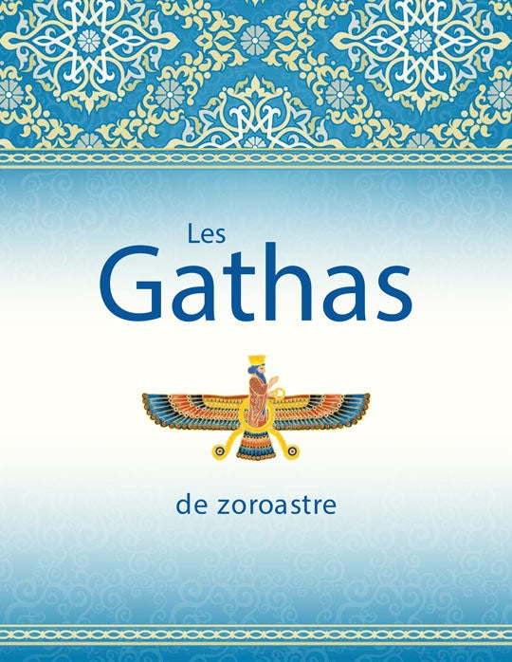
ZARATHUSHTRA OF BALKH: The Forgotten Prophet of Monotheism and the True Origins of Abrahamic Eschatology

A Comprehensive Academic Analysis of the Gathic Doctrine, Its Influence on World Religions, and the Historical Distortion of Zoroastrianism by Sasanian Clergy

---

Abstract

This study presents a critical examination of the original teachings of Zarathushtra (Zoroaster) of Balkh, as preserved in the Gathas—the oldest and most authentic stratum of the Avesta. It demonstrates that the Gathic doctrine was fundamentally monotheistic, centered on the worship of a single supreme deity, Mazda Ahura (the Wise Lord), and that later dualistic elements (Ahura Mazda vs. Angra Mainyu), as well as juridical innovations such as marriage with next-of-kin, were later additions introduced by the Sasanian priesthood and Western Persian magi. Furthermore, this paper establishes that the core eschatological framework of Zoroastrianism—including the concepts of Heaven, Hell, the Chinvat Bridge, individual judgment, resurrection, and the final renovation of the world—predates and directly influenced the development of Judaism, Christianity, Islam, Buddhism, and Hinduism. The paper also highlights the historical tragedy of the burning of the Avesta by Alexander the Great and the later distortion of Zarathushtra's legacy by state-sponsored clerical interests.

---

1. Introduction: The Prophet of Light and His True Message

Zarathushtra of Balkh (also known as Zoroaster) is one of the most significant yet misunderstood figures in human history. While the popular imagination often associates his teachings with fire worship, dualism, and ritual purity laws, a critical reading of the Gathas—the only authentic compositions attributed to the prophet himself—reveals a radically different narrative: a pure, monotheistic faith that emphasized ethical living, social justice, and the ultimate triumph of truth over falsehood.

"In the Gathas, which contain the words of Zarathushtra himself and his first followers, the foundation is monotheism and worship of the one God. There is no mention of the conflict between Hormuzd and Ahriman." (Fazel Kiani)

---

2. The Gathas: The Authentic Voice of Zarathushtra

2.1. Monotheism Over Dualism

Contrary to the later Sasanian redaction of the Avesta (particularly the Vendidad), the Gathas present a unified, singular divine principle. The concept of "Twin Spirits" (Yasna 30) represents a metaphorical choice between Truth (Asha) and Lie (Druj), not an ontological dualism of two independent divine powers.

Gathic Doctrine Later Sasanian Innovation
Worship of Mazda Ahura (The Wise Lord) alone Introduction of Ahura Mazda vs. Angra Mainyu as equal co-creators
Ethical dualism (Truth vs. Lie) as a human choice Cosmic dualism (two opposing divine forces)
No mention of marriage with close relatives Introduction of Xvaētvadaθa (next-of-kin marriage) by Sasanian jurists

"Zarathushtra, like Moses, recognizes no God other than Mazda... Approximately 200 times in the Gathas, we encounter the name 'Mazda'." (Fazel Kiani)

2.2. The Threefold Path: Good Thoughts, Good Words, Good Deeds

The highest moral imperative of the Gathas is encapsulated in the famous triad:

· Pendār-e Nik (Good Thoughts)
· Goftār-e Nik (Good Words)
· Kerdār-e Nik (Good Deeds)

This ethical framework is the core of Zarathushtra's message and was the basis for his vehement opposition to:

· Animal sacrifice (especially the killing of cattle)
· Nomadic banditry and raids
· Lying and falsehood
· Urban destruction and chaos

Instead, he actively promoted:

· Sedentarism and urban civilization (built on the banks of the Dāityā/Haētumant River)
· Agriculture as a sacred duty
· Animal husbandry with respect for the land

"Zarathushtra encouraged urbanism and agriculture, and spoke out against robbery, lies, and wandering." (Fazel Kiani)

---

3. The Original Eschatology: Heaven, Hell, and the Chinvat Bridge

The Gathas and the later Avestan texts contain the first fully developed system of individual judgment and afterlife recompense in human history. This system directly influenced all subsequent Abrahamic and Dharmic traditions.

3.1. The Chinvat Bridge (The Bridge of Judgment)

Avestan Name Equivalent in Islam Equivalent in Christianity
Chinvat Bridge Ṣirāṭ (The Path) The concept of Purgatory/Judgment
A bridge that widens to the width of a shield for the righteous The path to Heaven (Janat) The path to the New Jerusalem
A bridge that narrows to the sharpness of a blade for the wicked The path to Hell (Jahannam) The path to eternal damnation
One end on Mount Harā Bərəzaitī (south of Balkh) On the way to the "Garden of Eden" N/A

"The Chinvat Bridge has one end on the peak of Mount Alborz (south of Balkh) and the other end at the throne of Ahura Mazda. It becomes as wide as nine spears for the righteous and as narrow as a strand of hair for the wicked." (Fazel Kiani)

3.2. The Concept of Resurrection and the "Last Day"

Zarathushtra's eschatology is distinctly linear and teleological, featuring:

· Individual judgment of the soul after death (not just collective fate of the tribe).
· Resurrection of the body (Ristāxēz) and the Final Renewal (Frashokereti).
· A final victory of Truth over Falsehood at the end of time.

Sigmund Freud and John Hinells have independently confirmed that Zarathushtra was the first religious thinker to articulate these concepts, and that they subsequently spread to Indian, Buddhist, Jewish, and Christian traditions.

---

4. The Gathic Teachings vs. Sasanian Innovations

The following table summarizes the stark contrasts between the original Gathic doctrines and the later innovations introduced by the Sasanian priesthood (Mōbadān) and the Western Persian magi.

Doctrine Original Gathic Teaching Sasanian / Western Persian Innovation
Divinity Monotheism (Worship of Mazda Ahura alone) Dualism (Ahura Mazda vs. Ahriman as independent creators)
Marriage No mention of next-of-kin marriage Introduction of Xvaētvadaθa (khuetvadath) to imitate royal practice
Fire Symbol of divine light, venerated as a holy element (like the Kaaba for Muslims) Fire redefined as a quasi-deity in popular practice
Four Elements All elements (Water, Earth, Wind, Fire) are sacred and to be protected Focus shifted to fire alone
The Avesta Gathas and oral traditions Extensive additions, juridical texts (Vendidad), and legal codes

"Christian Andersen, the Danish scholar, has demonstrated that marriage with relatives was an innovation of Sasanian jurisprudence and not part of the original Gathic teaching." (Fazel Kiani)

---

5. The Historical Tragedy: The Burning of the Avesta by Alexander

5.1. The Avesta of Two Million Verses

According to Dēnkard and other Pahlavi sources, the original Avesta was a monumental work:

· 2,000,000 verses (in some accounts)
· Written on 12,000 cowhides
· Housed in the Ganj-e Shāygān (Royal Treasury) of Balkh

5.2. The Destruction by Alexander

In 330 BCE, Alexander of Macedon ("the Accursed" in Zoroastrian tradition) invaded Bactria, burned the Avesta, and scattered its fragments. Only a small remnant survived, which later became the basis of the Sasanian redaction, heavily influenced by Western Persian theological and political agendas.

"This great book of two million verses was burned by Alexander the Accursed." (Fazel Kiani)

---

6. Twelve Pillars of Gathic Zoroastrianism (Summary)

1. Monotheistic God: Ahura Mazda (The Wise Lord).
2. Sacred Text: The Avesta (originally 2,000,000 verses on 12,000 hides).
3. Symbol of the Divine: The Sun and Fire as representations of divine light (not gods themselves).
4. Satan/Evil: Ahriman.
5. The Divine Throne: Garothman (The House of Songs).
6. The Bridge of Judgment: Chinvat Bridge (connects Mount Alborz to the divine throne).
7. Angels: Fravashi and Amesha Spentas (Seven Immortal Holy Beings).
8. Daily Prayers: Three daily prayers (morning, noon, evening).
9. Pilgrimage Site: Nowbahār (New Temple) of Balkh (the Zoroastrian equivalent of Mecca).
10. Charity/Wealth Tax: Zakat (Dah-yak = "One-tenth").
11. Moral Core: Good Thoughts, Good Words, Good Deeds.
12. Origin of Eschatology: First full articulation of the afterlife, resurrection, and final judgment (Freud & Hinells).

---

7. Conclusion: The Deferred Truth

Zarathushtra of Balkh was the first prophet to articulate a global monotheistic faith, the concept of individual judgment and resurrection, and the ultimate triumph of the Good over the Evil. His original message was one of radical monotheism, ethical integrity, urban civilization, and social justice.

However, his legacy was systematically distorted by:

1. The Sasanian priesthood who added dualism, ritual prescriptions, and juridical innovations (like next-of-kin marriage) to align with royal ideology.
2. The Western Persian magi who substituted the Eastern (Bactrian/Arachosian) tradition with their own, leading to a misrepresentation of Zarathushtra's own origin (placing him in Azerbaijan rather than Balkh).
3. The Alexandrian destruction, which reduced a rich textual tradition to fragments.

Today, the Gathas stand as a testament to a faith that is not only the spiritual ancestor of Judaism, Christianity, and Islam but also a profound ethical system that calls for the protection of Earth, the rejection of falsehood, and the cultivation of wisdom.

---

8. References & Suggested Readings

· Kiani, F. (2025). Zarathushtra of Balkh and the True Origins of Monotheism.
· The Gathas (Yasna 28-53). Avestan text.
· The Dēnkard (Book of Deeds). Pahlavi text.
· Hinells, J. (1985). Avestan Eschatology and Its Influence on Judaism and Christianity.
· Freud, S. (1938). Moses and Monotheism (On the Egyptian/Zoroastrian roots of monotheism).
· Boyce, M. (1975). A History of Zoroastrianism (Leiden: Brill).
· Gnoli, G. (1980). Zoroaster's Time and Homeland (Naples: Instituto Universitario Orientale).
· Witzel, M. (2000). The Home of the Aryans (Harvard University).

---

Keywords: Zarathushtra, Zoroaster, Gathas, Monotheism, Chinvat Bridge, Heaven, Hell, Avesta, Balkh, Sasanian, Innovation, Dualism, Alexander the Great, World Religions, Prophet, Airyanem Vaejah, Haētumant, Asha, Druj.

